- The bare PCB is a panel measuring L: mm x W: mm . Each such panel contains 16 individual PCBs arranged in 4x4 matrix.
Top (component) view
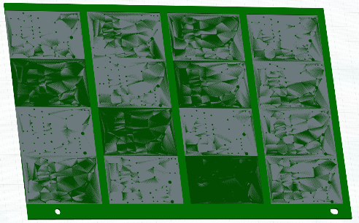
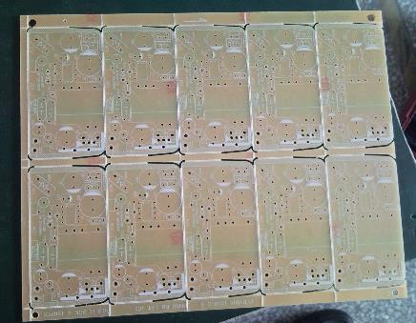

Bottom view

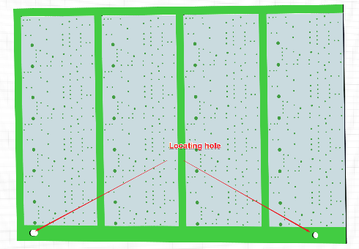

- A zoomed-in photograph of the bare PCB is shown below.

Top (component) view

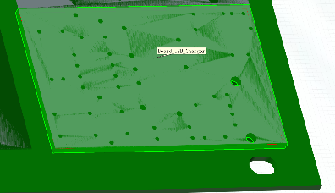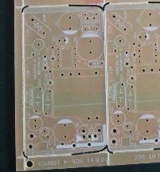
Bottom view

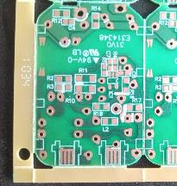

- The pictures of a fully assembled PCB are shown below.

Top (component) view
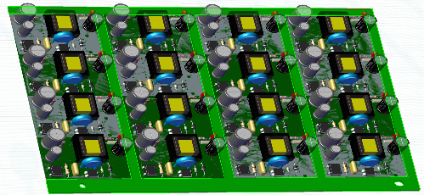
Bottom view

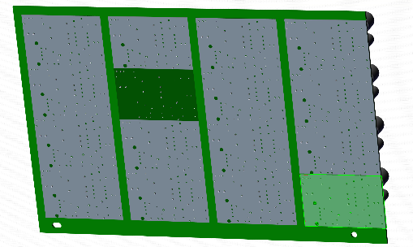
- A zoomed-in version of the fully assembled PCB is shown below.
Top (component) view
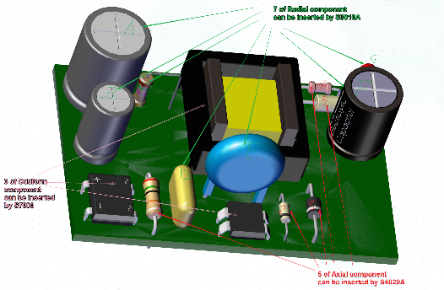
There are total of 15 thru-hole components that are inserted into the PCB. These inserted thru-hole components are highlighted on one of the individual PCBs of the panel.

Bottom view (after auto insertion：Axial and Radial component should be clinching)

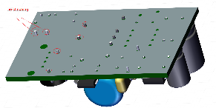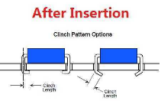
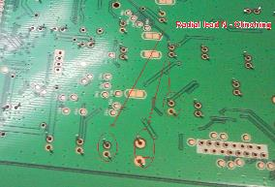
- The picture below shows individual thru-hole components that are inserted into the PCB.
Axial Lead component:

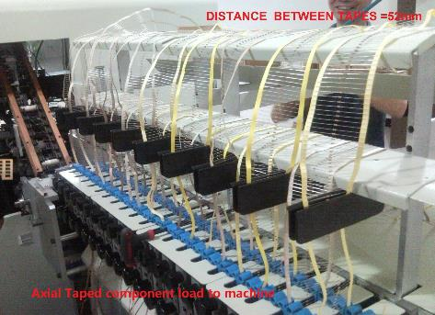

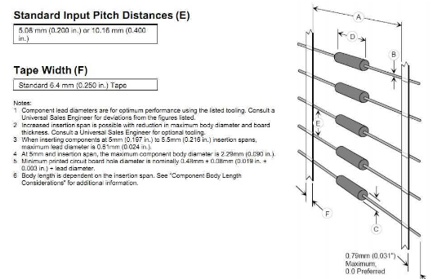
. 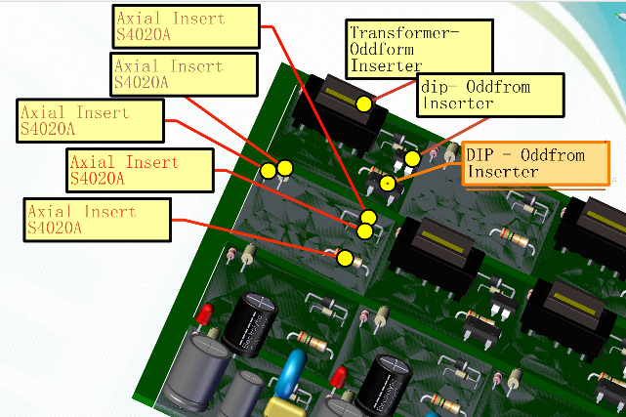lll'l'l'l'l'l'l'l'l'l'l'l'l'l'l'l'l'l'l
Radial Lead component:

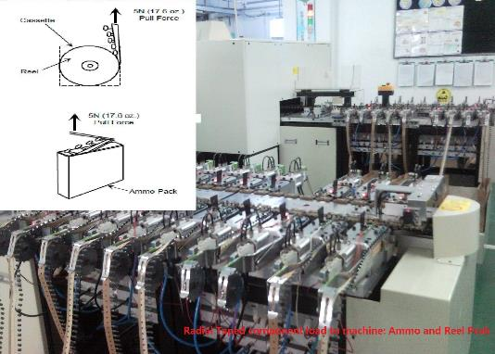
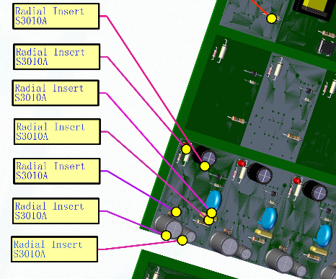

Oddform component:

